LYNCHBURG-CLAY MUSTANG FIGHT SONG
(Always STAND, CLAP & SING this song.)

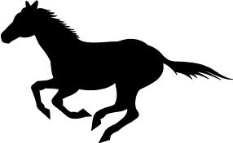
Go on you Mustangs,
On to victory.
With your colors flying,
You’re as mighty as can be. RAH, RAH, RAH

Go on you Mustangs,
Win this game tonight.
And fight for the fame of our fair name,
And loyal colors black and white.
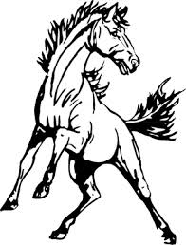
We’re the best team in the land!
Give our team a great big hand.
If you ask us we will say,
We are proud of Lynchburg-Clay
The Best! The Best!
We’re the team with all the zest. RAH, RAH, RAH

Go on you Mustangs,
On to victory.
With your colors flying,
You’re as mighty as can be. RAH, RAH, RAH

Go on you Mustangs,
Win this game tonight.
And fight for the fame of our fair name,
And loyal colors black and white.
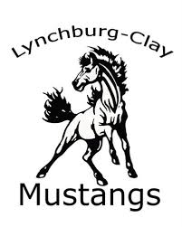
GO GO GO GO GO
FIGHT FIGHT FIGHT FIGHT FIGHT
WIN WIN WIN WIN WIN
GO FIGHT WIN!

